Lighting Design Basics
Based on the Book by Mark
Karlen and James Benya,
Wiley and Sons, 2004
Presented by
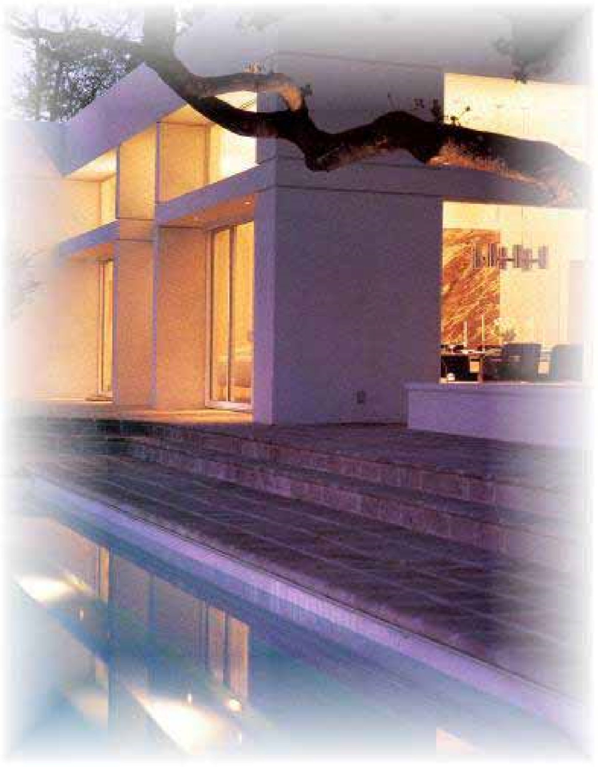
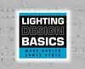
NKBA and
Benya Lighting
James Robert Benya, PE, FIES, IALD, LC
BENYA LIGHTING DESIGN
Portland, OR
No Handouts?!?!?
•Get the book
– www.wiley.com
•Download this presentation at www.benyalighting.com
•Questions? Send a message to jbenya@benyalighting.com
What are lighting design basics?
- Introduction
- Light Sources
- Luminaires
- Switching and Dimming
- Daylighting
- Lighting Calculations
- Documenting Lighting Design
- The Layers Approach
- A Basic Approach
What are lighting design basics?
- Residential Lighting Design
- Office and Corporate Lighting Design
- Hospitality Lighting Design
- Health Care/Institutional Lighting Design
- Lighting for Stores
- Lighting Common Spaces
What are lighting design basics?
- The Professional Process of Lighting Design
- Collaborating with Lighting Designers
- Computers and Lighting Design
- Developing Skills Beyond the Basics

1 Introduction
A GOOD LIGHTING DESIGN SHOULD • Look good!
- Provide the proper amount of light in every room.
- Be built and constructed within budget, code, and other constraints.
- Be environmentally responsible.
- Respond to the Architecture and Interior Design
- Produce good color
- Achieve the desired moods of each space
- Be able to control the lights

2 Light Sources
- Incandescent
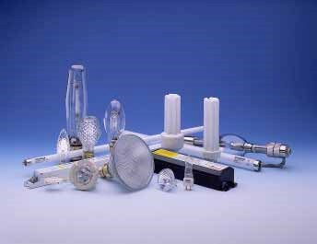
- Halogen
- Fluorescent
- Compact
Fluorescent Lamps
- LED’s
- Fiber Optic Sources

Incandescent Lamps
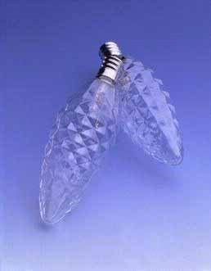
•Appealing
•Warm, attractive color
(2600-2900K)
•Dimmable
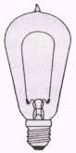
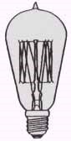
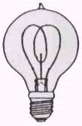
•Wide variety
•Not energy efficient
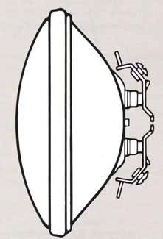
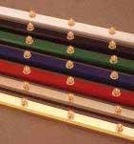
Low Voltage Incandescent

Lamps
PAR36 Long
- Usually low throw display wattage but not lamp 2700K
inherently energy efficient
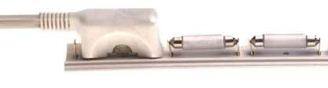
- Greatest advantage: sizeLow voltage
Xenon incandescent strip lights
strips and tubes 2400-
2600K
2800K

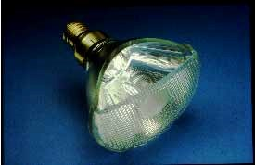
Halogen Lamps
•Appealing
Halogen PAR 20, PAR 30
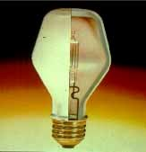
•Crisp warm, attractive and PAR 38 lamps color (2800-3100K)
•Dimmable
•Wide variety
•Longer life, slightly
more energy efficient Halogen lamps for table lamps and
chandeliers
Small halogen lamps for task lights, sconces, etc.

Low Voltage Halogen
- Compact, bright lamps
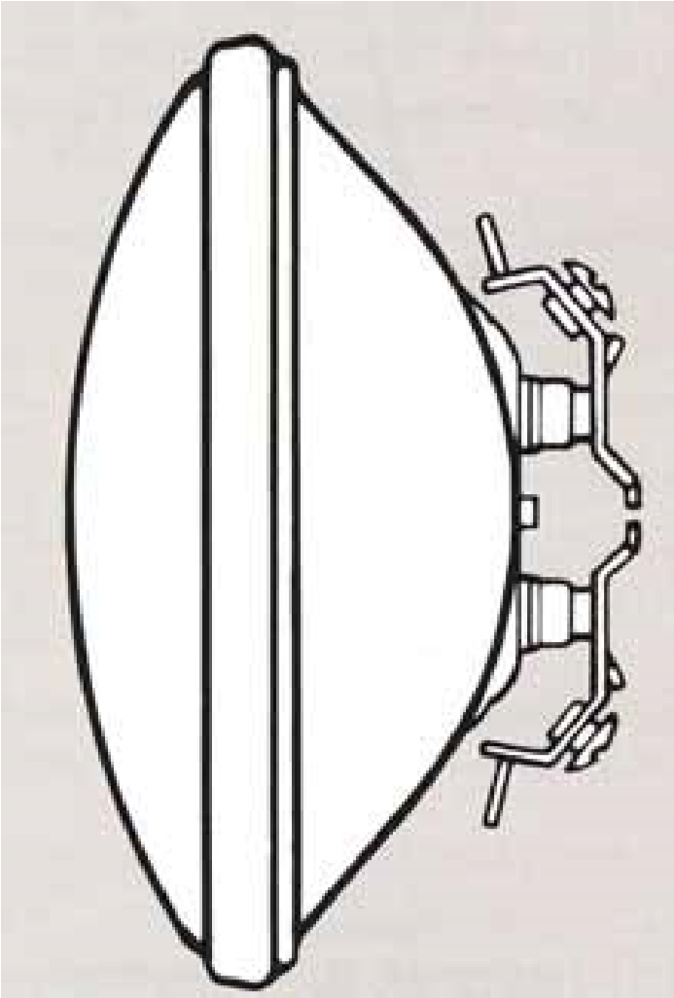
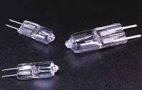
- A bit more energy efficient
PAR36 and
AR111
halogen
long throw
lamps
- Excellent reading, work and display light sources
- Color Temp: 2900-3100K
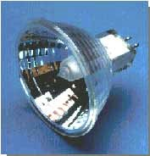
- Long life
MR16

Linear Fluorescent
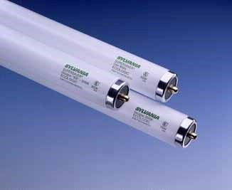
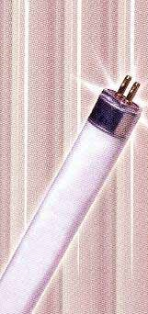
•T-12 “fat tubes” T-12 T-8 T-5 T-2 no longer a good choice
•Use T-8 lamps for most residential uses
•Consider T-5 and T-2 lamps for undercabinet fixtures
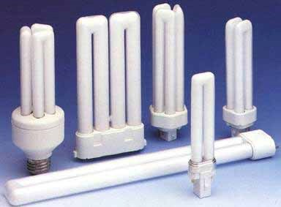
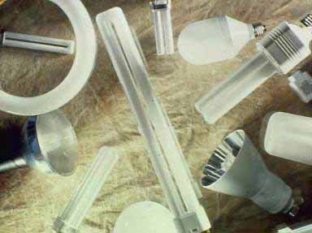
Compact

Fluorescent
•7,9, and 13 watt twin tubes (“PL” lamps) for step lights, low level lighting
•Triple tube,
Circuline and 2D lamps 18-58 watts for general lighting

Color temperature
Range of
Daylight

Warm Neutral Cool Cold
1800K 2800K 3500K 5000K 7500K 10000K
2200K 3000K 4100K 6500K
9000
K
Setting
Sun
North
Sky
Range of
Fluo
rescent
Range
of
Flame
Range of
Incandescent

and Halogen
Recommended Fluorescent

Lamps for Common Use
Desired Lamp Color  - Warm 2700K  - Warm 3000K  - Neutral 3500K  - Cool 4100K  - Cold 5000K | Lamp Color  Designation  - “827”  - “830” or “930”  - “835”  - “841”  - “850” or “950”
Example: F32T8/830 is a 3000K, 32 watt tubular fluorescent lamp 8/8” in diameter

Fluorescent Ballast Technology
•Non-dimming
electronic ballasts
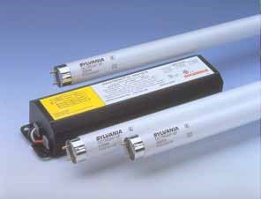
- Quieter – Instant starting
•Dimming
electronic ballasts
- Two wire versions now available
- Standard 3 wire and 4 wire versions also available

New Technologies
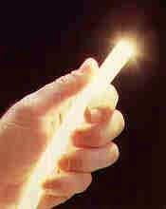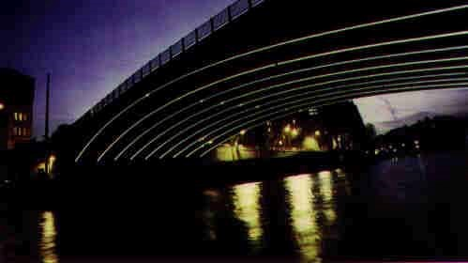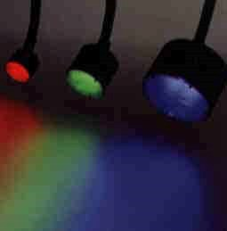
•Fiberoptics
•LED

Fiberoptics as Special Effect
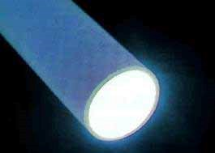
•End-emitting fiber
- twinkle effects (star fields)
- in-water effects (ponds and water features)
•Side Emitting fiber
- outlining
- shapes

Fiberoptics as Display Lighting
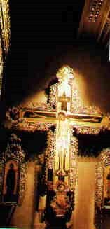
- Uses special optical elements (small lenses)
- Each fiber emits a very small amount of light
- Maximum bundle is about
300 cd at 30 degree
- Virtually no UV or IR
- Requires a low ambient light space like a fine museum

LED Lights
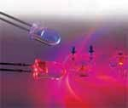
- Promising technology
- Used for traffic signals and exit
signs
- New products include sconces, step lights and marker lights
For the Kitchen and Bath

My favorites
Kitchen
- PAR38 halogen work area downlights
- MR16 low voltage accent lights
- Low voltage xenon or fluorescent undercabinet lights
- Fluorescent cove lights
Bath
- Halogen or fluorescent vanity
lights
- MR16 vanity downlight and accent lights
- MR16 shower light

Urban Living Trends
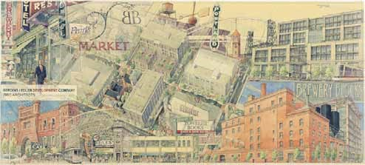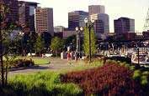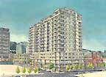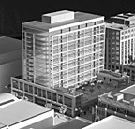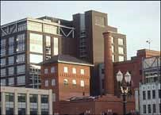
•Smaller, higher quality spaces
•Green design

Challenges of Green Design
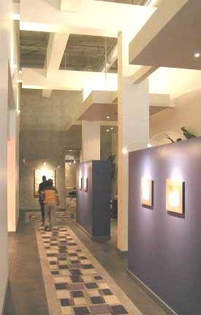
- Too much emphasis on compact fluorescent lighting
- Little understanding of lighting design by utility and energy efficiency advocates
- Not many good choices of luminaires embodying green principles
- Poor design sensitivity in the green community
For the Kitchen and Bath My green favorites
Look for US EPA Energy Star but be picky!

Kitchen
- Compact
fluorescent work area downlights
- MR16 low voltage accent lights
- Low voltage fluorescent undercabinet lights
- Fluorescent cove lights
Bath
- Fluorescent vanity lights
- MR16 vanity downlight and accent lights
- MR16 shower light

3 Luminaires
- “Architectural”
  - Recessed cans
  - Track
  - Coves and undercabinet lights
- Decorative
  - Chandeliers
  - Sconces
  - Pendants
  - Lamps
- Utility
  - Drums
  - Closet lights
Recessed Lighting
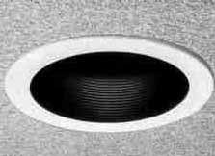
- Generally inexpensive
- Very popular
- Aesthetically “neutral” • Good for task lighting
- OK for general lighting
- If chosen correctly, excellent for display lighting and a number of special applications

Recessed Lighting
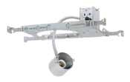
- The “Housing”
  - For most residential use, fixtures are at most about 7” tall for
2x8 construction
- The “Trim”
  - 4”, 5” and 6” incandescent
  - 3”, 4”, 5” and 6” low voltage
  - 4”, 5” and 6” compact fluorescent

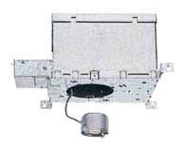
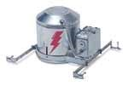
Standard Housings
- Incandescent non-IC
- Incandescent IC
- Incandescent air tight IC
- Low voltage non-IC
- Low voltage IC
- Low voltage airtight IC • Compact fluorescent non-

IC
- Compact fluorescent IC
- Compact fluorescent airtight IC

Remodeler Housings
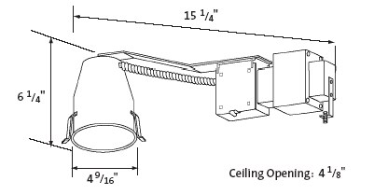
•Designed to fit through a single hole in the ceiling
•Usually not IC

Premium Housings
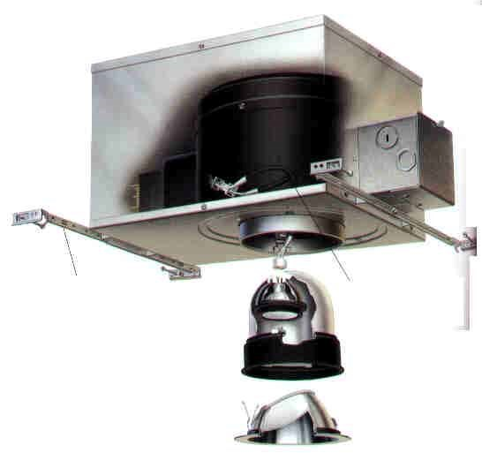
•Superior quality
•Interchangeable
lamp capability
- Incandescent
- Low voltage – Compact fluorescent
•High quality
interchangeable trims

Choosing Trims
- Is the trim suitable for your needs
  - Adjustable?
  - Right style?
  - Right color or material?
- Is the trim LISTED for the application?
  - Kitchen: indoor, dry location
  - Bathroom: indoor, dry location
  - Over shower or tub: Spa or shower rated
  - Steam shower: wet label, gasketed
  - Indoor pool or hot tub: wet label, non conductive trim, at least 7.5’ above water level

Standard trims
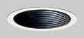
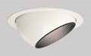
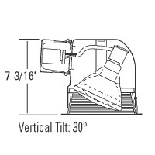
- Downlight
  - Baffle
  - Cone
- Accent light
  - Gimbal – Eyeball – Pull down
- Wallwash
  - Eyelid

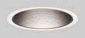
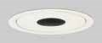
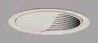
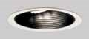
Using Standard Recessed Lighting
• Choose trims tastefully • Use halogen lamps
- 4” family use PAR20
- 5” and 6” family use
PAR30
- 6” family also consider the
PAR38
- Avoid so called line voltage MR16 and PAR16
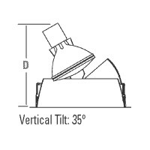
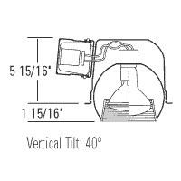
Adjustable
Line Voltage
Recessed
Trims

Low Voltage MR-16 Lighting
- Typically used in a 3” or 4” recessed can
- Can be used (with the right trim) in a 5” or 6” can
- Use good quality MR16 lamps
- ALWAYS use a soft focus spread lens (Halo L111)
- Current Favorite: Sylvania 37MR16/IR
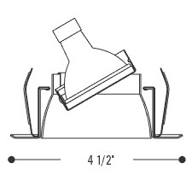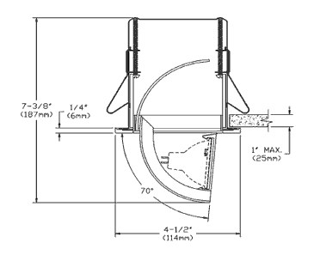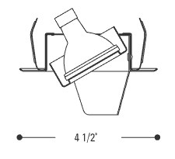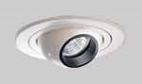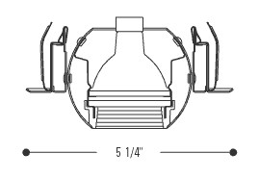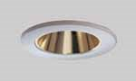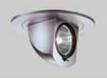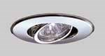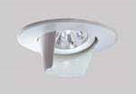
Low Voltage Trims

Other Low Voltage Trims
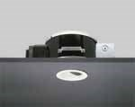
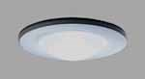
•Glass trim, gasketed for wet environments
•Low cost spa and shower
light for tubs and shower
stalls
Be Careful with Compact

Fluorescent Downlights
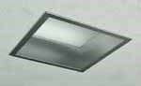
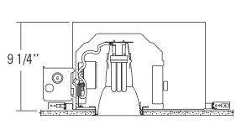
- Square: not IC or AT but looks nice
- Round IC – way tall
- To get an airtight IC you are limited to 13 watts
- In the kitchen downlight you need 32 watts
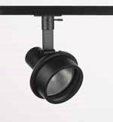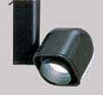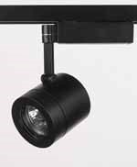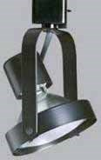
Track
- Still used in museums for good reason
- Permits maximum flexibility
- Luminaires equipped easily with spread lenses and UV filters for artwork lighting
- Attaches to surface, permits dramatic lighting in condos

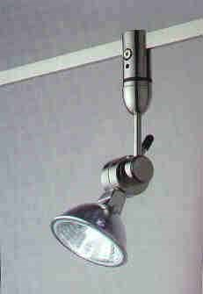
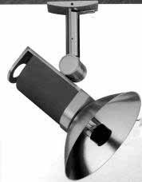
Track
- Standard 120 volt track
  - Low cost general purpose
  - High cost “museum grade”
- Low voltage track
- Low voltage specialty systems
  - Two cable systems
  - Two rail systems
  - Two conductor “bars”,
“rods”, and ribbons

Low Voltage Lighting
•Most recessed low voltage lights have a
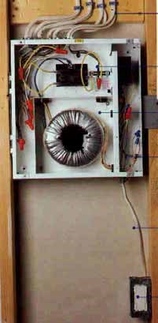
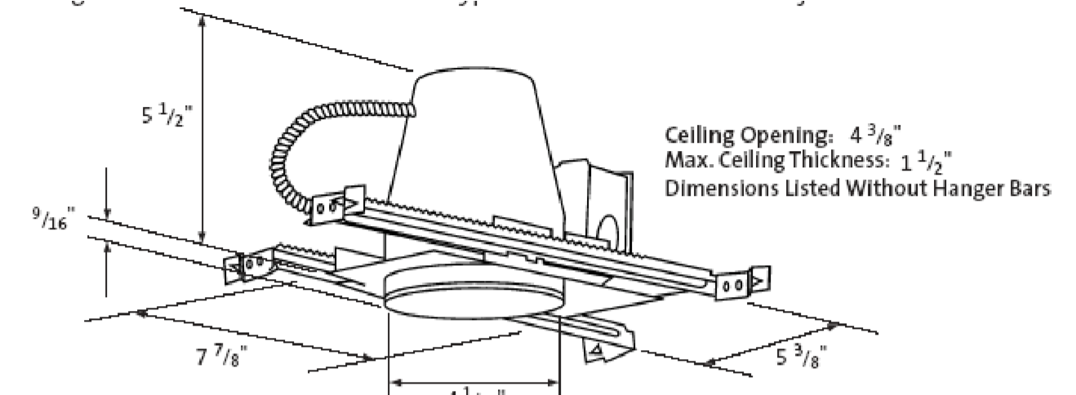
transformer in the housing
•Most low voltage strips and some recessed housings can be connected to a remote transformer

Accent Lighting Using Low Voltage
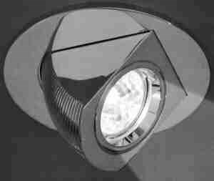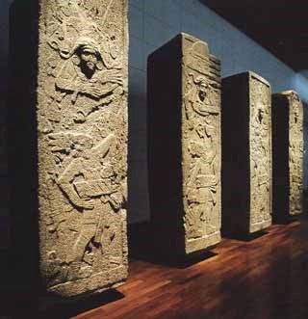

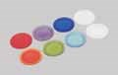
Beam Quality
An unfiltered lamp tends to have
- Striation
  - lines and harsh edges
- Halation
  - rings sometimes with rainbowing
- Sharp edges and rapid change
  - well defined round or elliptical beams

Taming the (MR16) Beast
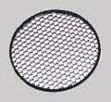
- Smooth the Beam
  - Softening Lens (Halo L111 or “solite”) – Spread Lens
  - Linear Lens
- Shield the Source
  - Baffle or snoot
  - Louver

Accent Lighting Technique
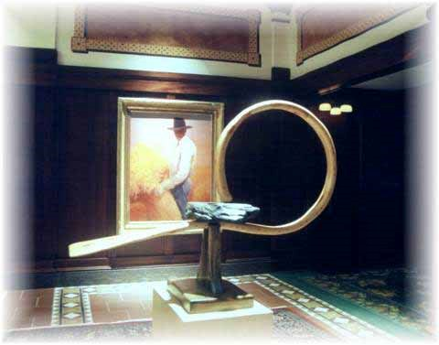
- Should be located at about 30 degrees off vertical relative to focal point
- Do not get too close to wall normally 24” minimum away
- Use 30-60-90 triangle to determine optimum position
- Only use lighting systems capable of hitting above 40 degrees (off vertical) in special situations.

Accent Lighting
Artwork
30
-
60
-
90
triangle
Mounting Line
Recessed accent light
Track or monopoint
The distance from the
fixture to the artwork
will determine
beam angle and
candlepower

Accent Lighting with PAR36
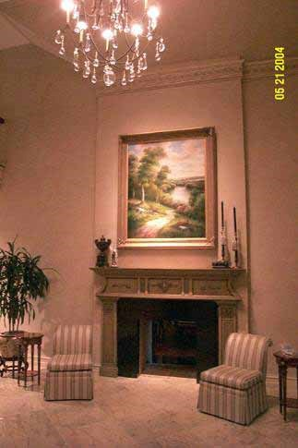
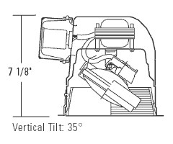
For high ceilings use a low voltage 6” recessed luminaire and a 50 watt PAR36 low voltage
lamp

Accent lighting
- Living room, great room, family room
- Dining room
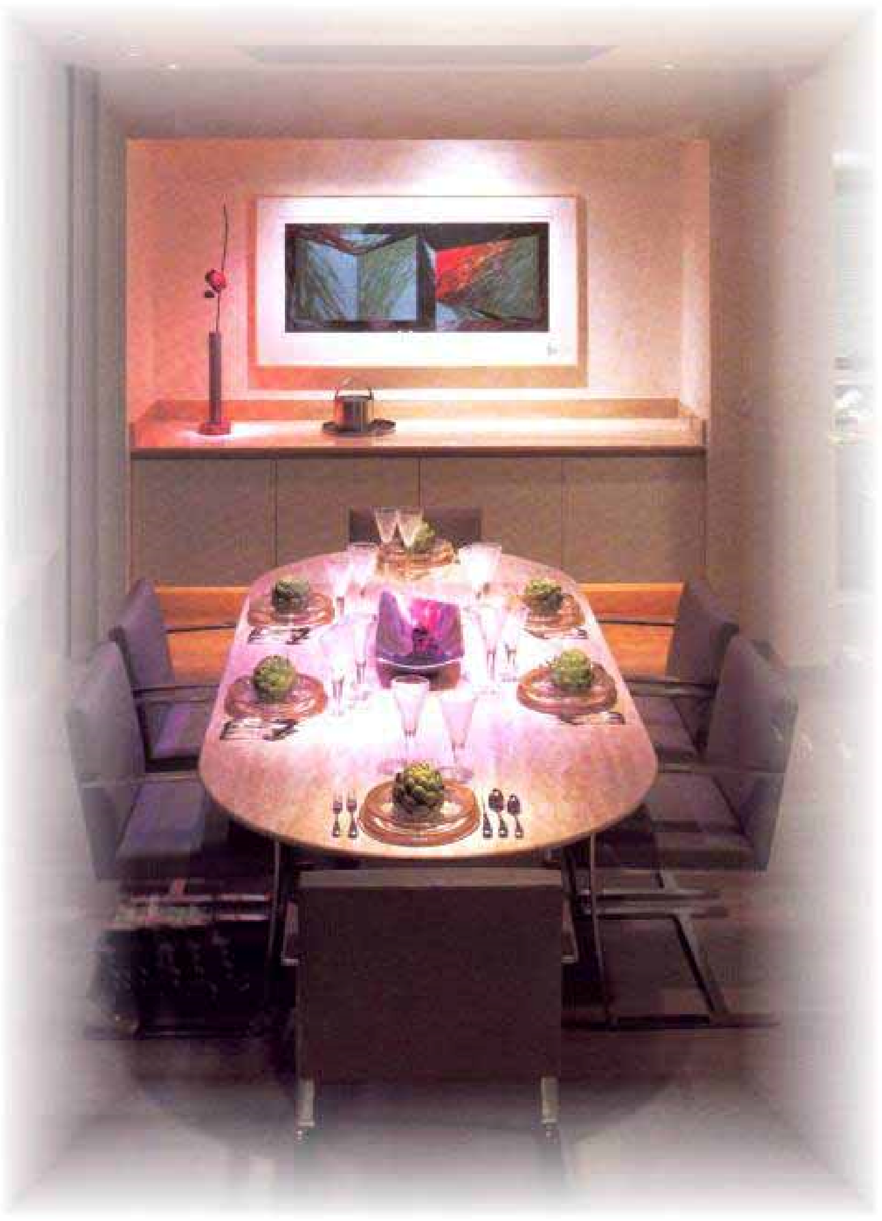
- Foyer
- Hallways/prime art locations
- Art niches
- Master bedroom
reading and art lights
- Powder rooms

The Layered Approach to Lighting Design
Begin by thinking in layers
Decorative

Focal

Task

Ambient

Layer #1 - The Ambient or General Lighting Layer
- Generally the relatively uniform lighting of the space.
- Tends to establish mood.
- Includes uniform downlighting, indirect lighting (uplighting and wallwashing), and some special techniques, but can also be the decorative lighting
- Called “general lighting” if at task levels (30-50 fc or more).
- Called “ambient lighting” if lower than task levels

The Ambient Layer
Cove lighting

Layer #2 - The Task Layer
•Generally limited to “task lighting” of the HORIZONTAL WORK SURFACE at work locations.
•Tends to help create drama.
•Usually produces 50 fc or more within a small area.

Ambient and Task Lighting
Downlighting

Layer #3 - The Display or Focal Layer
- Generally limited to accent lighting and similar effects, primarily through
VERTICAL AND OTHER NONHORIZONTAL SURFACE ILLUMINATION.
- Tends to create drama, with greater drama the result of greater contrast between the brightness created by Focal Lighting and Ambient Lighting.
- Usually involves key displays at 100 fc or more.

Ambient, Task and Focal Lighting
Accent Lighting

Layer #4 - the Decorative or Traditional Layer
- In general, adds the decorative luminaires called for by the architecture/interior design style, period, motif.
- Is usually expected to contribute to the ambient illumination. In many designs, the decorative lighting will BE the ambient lighting.
- Usually reduces contrast (drama).

Ambient, Task, Focal and Decorative Lighting
Chandelier

Composition
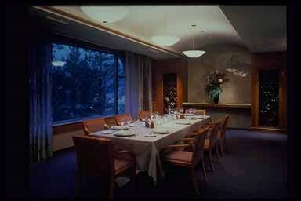

Composition
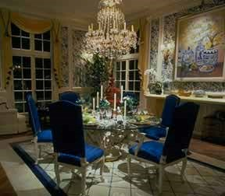
•Chandelier (ambient and decorative)
•Recessed (task)
•Recessed
(focal)
•Sconce
(decorative)

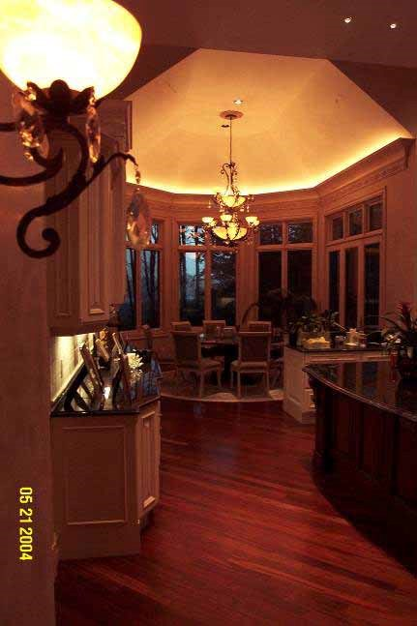
Composition
•Cove (ambient)
•Recessed (task)
•Undercabinet
(task)
•Chandelier
(decorative)
•Sconce
(decorative)

Composition and Planning for Change
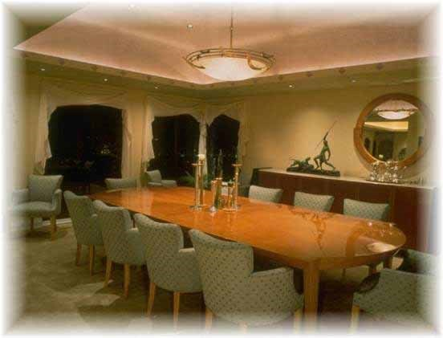
•Recessed adjustable lighting
•Combined with fixed predictable lighting

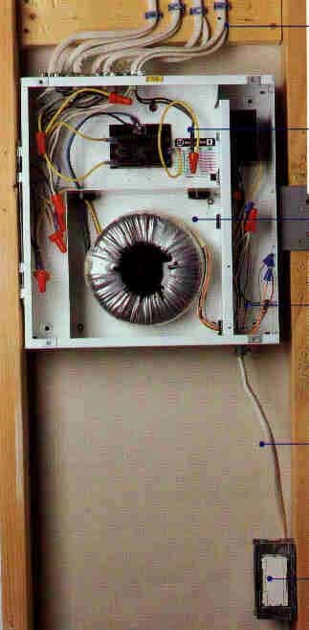
Remote transformers
•Address Article 411 and 725 issues
- Class 1
- Class 2
•Low noise, minimum heat

Wallwashing
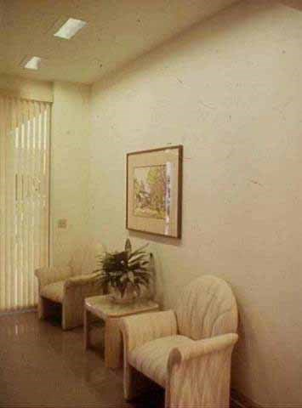
Produces a flat, even wash of light for a wall. You may find this is NOT what
you wanted…

Types of Wallwashers
Rececssed asymmetric style
Eyelid style
Recessed lens style
Track and surface lens and asymmetric style

Semi-recessed lens and open asymmetric style

Principles of Wallwashing
- Fixtures at least 24” out from wall and
about 1/4 wall The higher thewall the further
height out from wallout to locate
- Fixtures apart 1 to wallwashers
1.5 times the distance from the wall
- If you don’t need at least three - you At least 2’ shouldn’t be wallwashing

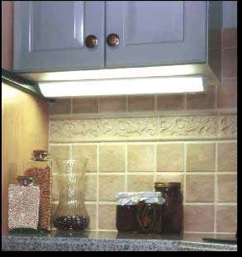
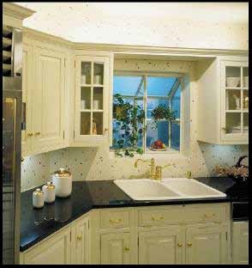
Undercabinet Lighting
DON’T
- Mount fixtures at back of cabinet
- Use luminous front fixtures
- Put short fixtures under long cabinets
- Put in cheap cool white or daylight lamps

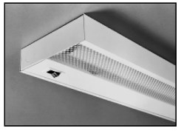
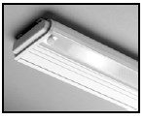
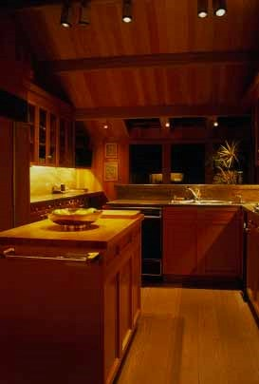
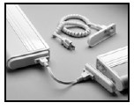
Undercabinet Lighting
DO
- Use solid front fixtures
- Use a lens to diffuse the lamp image over polished countertops
- Choose fixtures to be as continuous as possible and wrap around corners

Low Voltage Specialty Lighting
- Permits finely detailed lighting effects
- Use inside and under cabinets and similar locations
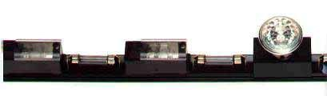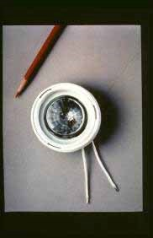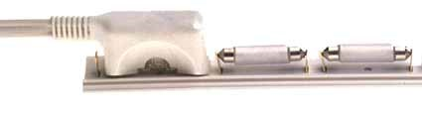

Example: Bookcase
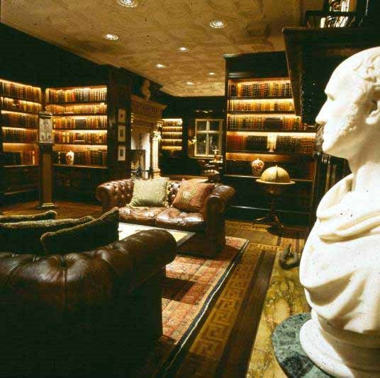

Example: Cabinet with Polished Countertop
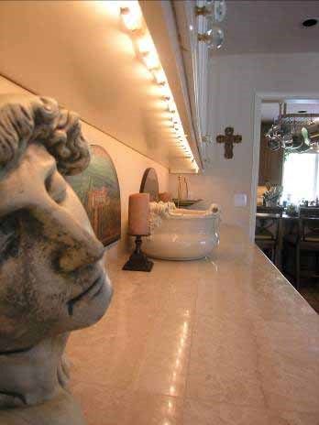

Things to Remember: Room by Room
•Here is my basic list of lighting considerations
•I use this with every client – we expand from there

Kitchen
•Multiple layers permits multiple
moods

Steps to Better Kitchen Lighting by Layers
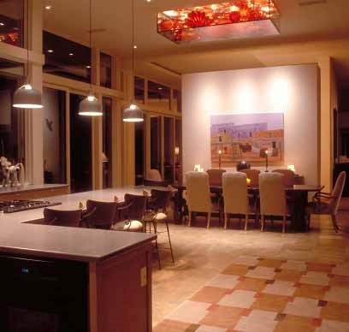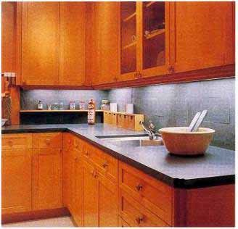
Layer #1 –
L
ight
the Task

Steps to Better Kitchen Lighting by Layers
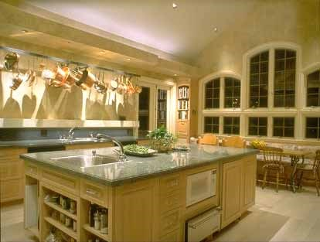
Layer #2 – Ambient
Light

Steps to Better Kitchen Lighting by Layers
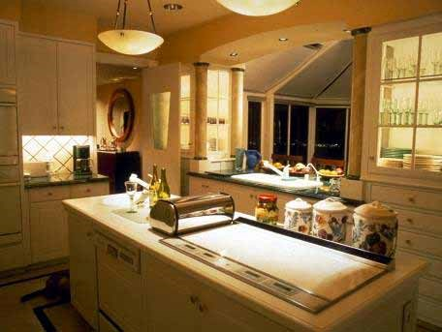
Layer #3 – Decorative
Light

Bathroom
Layers
•Multiple layers for mood and
flexibility
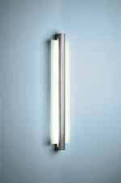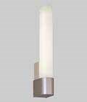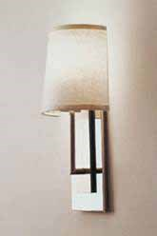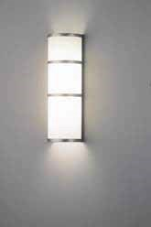
Bathroom
Layer #1-Task
Light the Face
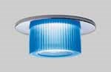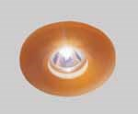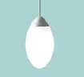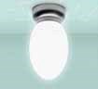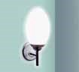
Bathroom
Layer #1-Task
Light the Face

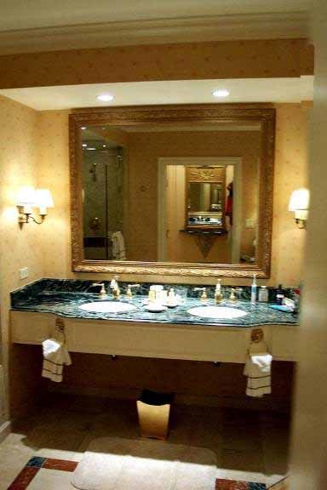
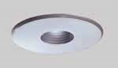
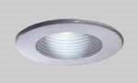
Bathroom
Layer #2-Task
Light the Sink

Bathroom
Layer #3-Task
Light the
Shower or
Tub
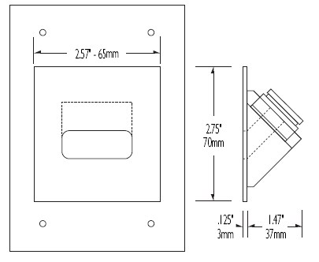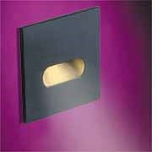
Bathroom
Layer #4-
N
ight
Lights

Other Lighting Things to Remember
- Dimmers and • Controlled controls laid out daylight ^{well and kept} • Lens, focus and
simple other
- Layers in every adjustments must space even be done ^{closets} • Good lighting
- Built in night lights extends outdoors

Lighting Design Basics

Presented by BENYA LIGHTING DESIGN
For a copy of these slides, www.benyalighting.com

